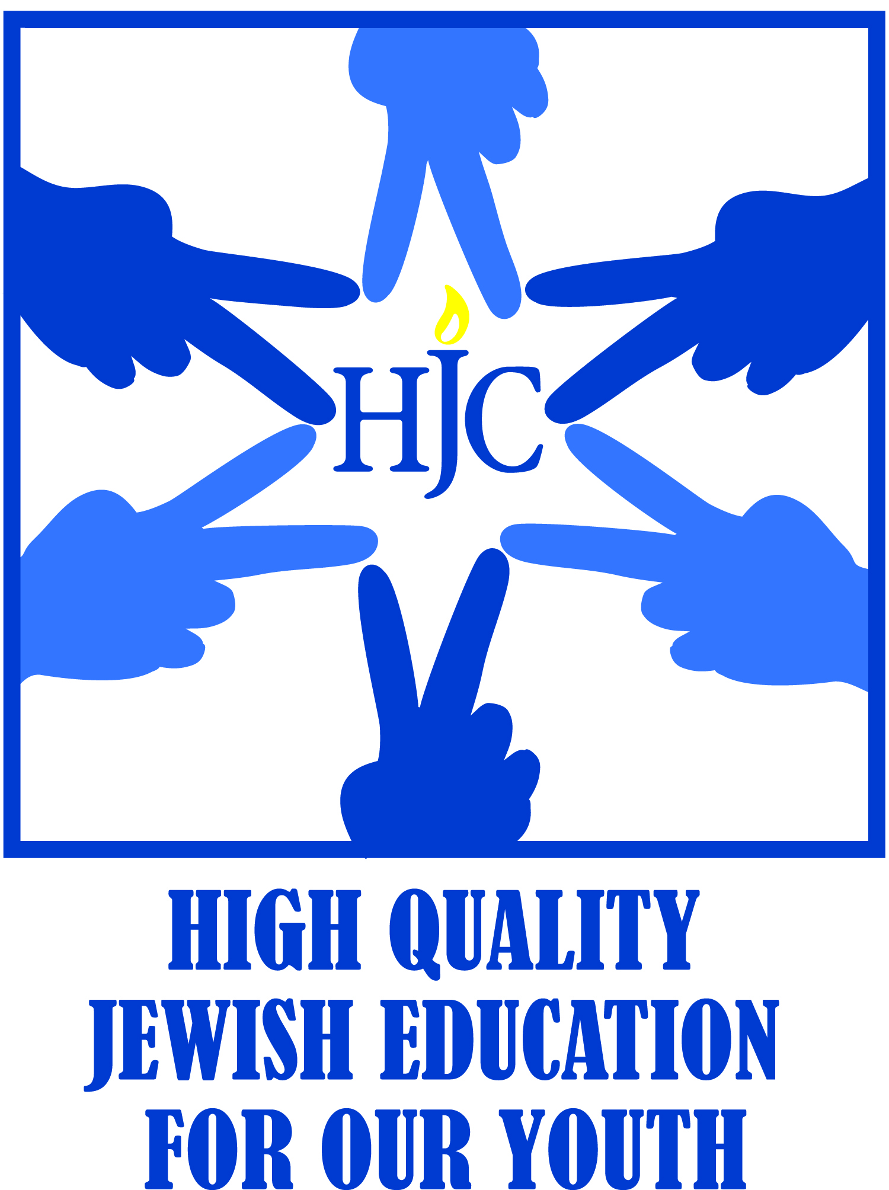

VAV WORKSHOPS 5779

Since the heart and soul of our religion is based on Torah and tradition, we are offering, as is our tradition, our Vav Family workshops in preparation for your upcoming Bar/Bat Mitzvah.

You as a family will benefit from attending all the sessions listed below.
The 6 workshops are designed to give you intellectual and spiritual preparation time, as well as the information you will need for this big moment in your family’s life. If you know in advance that you will have to miss a session please contact me ASAP Mfisher@hjcny.org or call 631-427-1157.

Please mark your calendars if you have not already done so!

MARCH 3RD with Rabbi Ari Saks
MAY 19th with Rabbi Ari Saks
DECEMBER 16th with Rabbi Ari Saks
JANUARY 13th with Dr. Cindy Dolgin
FEBRUARY 3rd with Lester Fox: Tallit and Tefillin
MARCH 31th with Dr. Cindy Dolgin: Presentation of your D’var Torah

PLEASE NOTE TIMING
All workshops will start at 9:00 in the Lief Chapel with a Family Friendly morning minyan.

Lester Fox’s workshop starts after the World Wide Wrap and breakfast

